[MS SQL: get permissions of a fixed server role](https://dba.stackexchange.com/questions/279886/ms-sql-get-permissions-of-a-fixed-server-role)

 need to get a list of MS SQL Server fixed roles and their permissions.

There is a query to get all server-level permissions:

SELECT \* FROM sys.fn\_builtin\_permissions('SERVER') ORDER BY permission\_name;

And there is a SP sys.sp\_srvrolepermission which returns list of server roles and their 'permissions'. But those permissions don't really map to what the previous query returns.

There is a pretty good explanation here <https://learn.microsoft.com/en-us/sql/relational-databases/security/authentication-access/server-level-roles?view=sql-server-ver15> with image, which shows roles and permissions. And permissions on the image map to the first query results.

[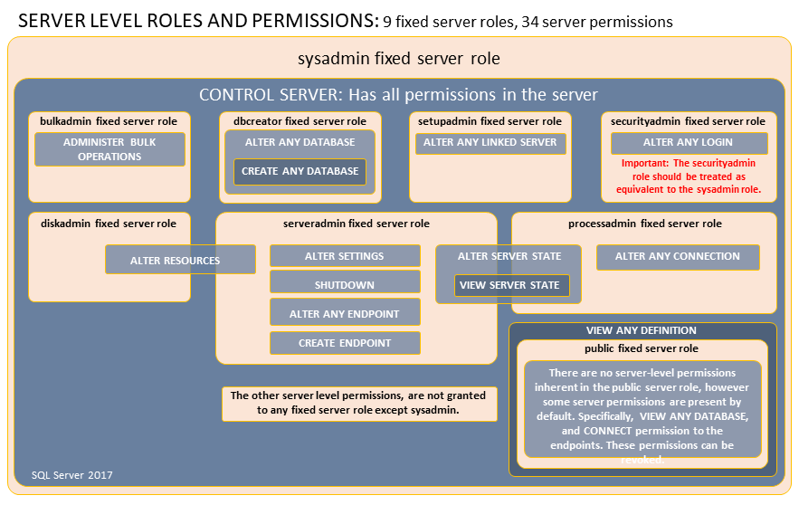](https://i.sstatic.net/sgdyY.png)

The question is - is there a correct way (SP, query) to get server fixed roles to permissions mapping, or should I hardcode those as per image.

* [**sql-server**](https://dba.stackexchange.com/questions/tagged/sql-server)

[Share](https://dba.stackexchange.com/q/279886)

[Improve this question](https://dba.stackexchange.com/posts/279886/edit)

Follow

asked Nov 18, 2020 at 11:08

[[](https://dba.stackexchange.com/users/218900/berliner)](https://dba.stackexchange.com/users/218900/berliner)

[berliner](https://dba.stackexchange.com/users/218900/berliner)

**111**22 bronze badges

* My goal is to have a program (in C#, but it doesn't matter) which can fetch system roles and their permissions from different MS SQL Server installations. I'm sure they will be of different versions. So I'm not sure if this picture is true for ALL possible versions. This is why it would be better to query server for this info. Now it looks like I can get system roles but not their permissions..

– [berliner](https://dba.stackexchange.com/users/218900/berliner" \o "111 reputation)

[CommentedNov 18, 2020 at 18:54](https://dba.stackexchange.com/questions/279886/ms-sql-get-permissions-of-a-fixed-server-role" \l "comment547038_279886)

[Add a comment](https://dba.stackexchange.com/questions/279886/ms-sql-get-permissions-of-a-fixed-server-role)

1 Answer

Sorted by:

                                              Highest score (default)                                                                   Date modified (newest first)                                                                   Date created (oldest first)

**0**

Maybe [this](https://www.red-gate.com/simple-talk/sysadmin/data-protection-and-privacy/introduction-to-sql-server-security-part-5/) is what you are looking for:

SELECT SYS.SERVER\_ROLE\_MEMBERS.ROLE\_PRINCIPAL\_ID,

ROLE.NAME AS ROLENAME,

SYS.SERVER\_ROLE\_MEMBERS.MEMBER\_PRINCIPAL\_ID,

MEMBER.NAME AS MEMBERNAME,

MEMBER.TYPE\_DESC,

PERMISSION\_NAME,

STATE\_DESC,

CLASS\_DESC

FROM SYS.SERVER\_ROLE\_MEMBERS

FULL JOIN SYS.SERVER\_PRINCIPALS AS ROLE ON SYS.SERVER\_ROLE\_MEMBERS.ROLE\_PRINCIPAL\_ID = ROLE.PRINCIPAL\_ID

FULL JOIN SYS.SERVER\_PRINCIPALS AS MEMBER ON SYS.SERVER\_ROLE\_MEMBERS.MEMBER\_PRINCIPAL\_ID = MEMBER.PRINCIPAL\_ID

FULL JOIN SYS.SERVER\_PERMISSIONS PERMISSIONS ON PERMISSIONS.GRANTEE\_PRINCIPAL\_ID = MEMBER.PRINCIPAL\_ID